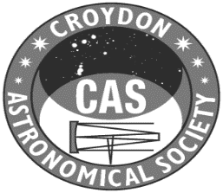 | Agenda for the Annual General Meeting  Friday 6th June 2025 at 7:40 pm

- Welcome from the Chair.
- Approval of the minutes of the 2024 AGM.
- Presentation of the 2024/25 Trustees’ Annual Report and Accounts
- Announcement of nominations for Committee.
Nine places are available for appointment at this AGM – the secretary (Graham Cluer) is not required to retire until the next following AGM.
Stefan Blakemore, Roy Easto, Carolyn Raishbrook, Paul Stenning, Laura Quayle, and Chris Entwistle were proposed by Graham Cluer and seconded by Tony Roberts. Tony Roberts has been nominated by Graham Cluer and seconded by Stefan Blakemore.
- Appointment of the CAS Accounts Examiner for the year to 31stMarch 2026.
- Any other urgent business.

