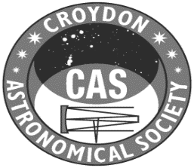 | Agenda for the Annual General Meeting  Friday 5th June 2026 at 7:30 pm

- Welcome from the Chair.
- Approval of the minutes of the 2025 AGM.
- Presentation of the 2025/26 Trustees’ Annual Report and Accounts
- Chair’s Report
- Announcement of nominations for Committee.
Eight places are available for appointment at this AGM – the Chairman (Stefan Blakemore) and the Treasurer (Roy Easto) are not required to retire until the next following AGM.
Peter Bartholomew, John Maltby, Carolyn Raishbrook, Sandra Reddy, Tony Roberts, Paul Stenning, Laura Quayle, and Graham Cluer were proposed by Stefan Blakemore and seconded by Roy Easto.
- Appointment of the CAS Accounts Examiner for the year to 31stMarch 2026.

Following the AGM there will be an opportunity for a general discussion.

